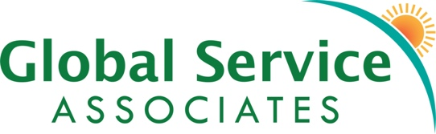
A Community of Servants in Mission

Electronic Giving Request
☐ Yes, I/we authorize Global Service Associates to initiate debit entries directly from my/our account maintained at the bank named below. The debit will occur (Select one)
Monthly (choose day) ☐ On the 5th ☐ On the 20th ☐ One time ☐ Annually
Start date of donation: _____________________
My bank information: (Attach a voided check)
The account is: ☐ Checking ☐ Savings 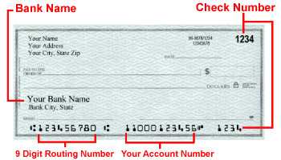
Bank Name _____________________________________
City _____________________________ State ___________ Zip Code ______________
Routing Number ____________________ Account Number _______________________
Each donation is to be designated to Global Service Associates account as indicated:
$ _________ Preference for ___________________________ (Name of member or project)
This authority is to remain in full force and effect until Global Service Associates has received written notification from me (or either of us) of its termination in such time and in such manner as to afford Global Service Associates and my bank a reasonable opportunity to act on it.
Name (please print) ______________________________________ Date _____________
Address ___________________________ City ______________ State _______ Zip ______
Phone Number ____________________Email Address _____________________________
Signature __________________________________________________________________
Global Service Associates P.O. Box 20425 Boulder, CO 80308
**If you have any questions, call Diane Murray, Donor Services, 303-214-5331, ext. 2 or email Diane at diane.murray@globalassociates.org

